THE COMMON PARISH COUNCIL OF SUTTON & BARLAVINGTON
MINUTES OF THE PARISH MEETING
MONDAY 3rd JULY 2023, 7.30PM

In attendance: Cllr Parkes, Cllr Andrews, Cllr Brown, Hannah-Louise O’Callaghan (parish clerk)  Agenda Item 1: Apologies for Absence  None  Agenda Item 2: Code of Conduct  - Declaration of Members’ Personal Interests on items included in the Agenda and Dispensation Requests - None  Agenda Item 3: Approval of Minutes of meeting held on 17th May 2023  On a proposal by Cllr Brown and seconded by Cllr Parkes it was RESOLVED that the Minutes of the meeting held on 17th May 2023 be accepted as a true record of proceedings. Cllr Andrews signed the minutes accordingly.  Agenda Item 4: Update on any matters carried forward from previous meeting not covered elsewhere  - Purchase of Coronation bench – no update  Agenda Item 5: Finance  Finance  - To approve Clerks salary and expenses – Appendix A  On a proposal by Cllr Brown and seconded by Cllr Parkes, Clerks salary and expenses were approved by the Council  - To note and approve income and expenditure report – Appendix B  On a proposal by Cllr Brown and seconded by Cllr Parkes, Council approved the income and expenditure report  - To approve the regular Bank Reconciliation – Appendix C  On a proposal by Cllr Andrews and seconded by Cllr Brown, the Bank Reconciliation was approved by the Council  Agenda Item 6: Highways, Footpaths and Village Maintenance Update  Cllr Brown reported that she had reported the Bignor footpath as well as the one running from Bignor Hill to the Downs as both are overgrown  Agenda Item 7: Planning Update  None  Agenda Item 8: District Councillors Report – John Cross – Chichester District Council  The following report was provided in advance by Cllr Cross:  You will all heard of the tragic accident that occurred on Saturday evening 3rd June on Duncton Hill, just beyond the row of houses at the top of the hill. The crash involved two vehicles and sadly three people lost their lives. It is one of the most dangerous stretches of road in the country and once again it has claimed more victims. I will be working with Tom Richardson, the county councillor, to see, when the police report on the incident, what further measures we can implement to help reduce the number of accidents. Those that use this road know how frustrating it can be to follow a very slow vehicle for miles, but for the sake of a few minutes the risk is not worth putting you and others in danger.  I was concerned to hear about the closure of the nursery provision at Graffham and Fittleworth early in the month. My concern is based on these providing logical next level entry children to the enfant schools, if these nursery schools are not there then where do the children, and what is the knock-on effect to parents having to travel further. The obvious other thought is that these children once in nursery school further away will naturally sign onto the enfant school where their friends are, and therefore reduce the school children at Graffham and Fittleworth. I hope this resolves itself with new nursery schools opening in the fall, but I am interested to hear parent’s views and how this may be affecting you.  In the early days of my new position, I am obviously learning a new job and trying to catch up on where my predecessor left off. For a single seat ward, it has the most parish councils, seven, of any in the district, so it’s quite a challenge to get around to them all. But it is interesting meeting and getting around the ward seeing the complex and difficult problems that need addressing for different communities, it is very rewarding.  Agenda Item 9: County Councillor Report, Tom Richardson  No report  Agenda Item 10: Correspondence  The Council noted the email from Paul Griffiths regarding a lady in Barlavington Care Home, it was agreed that Cllr Cross should sign the necessary forms  Agenda Item 11: Resignation of Clerk and handover  Council agreed that the Clerk would arrange for Cllr Cross to collect the remaining files and laptop. After discussion regarding a new possible Clerk identified by Cllr Parkes it was agreed that Cllrs Parkes, Andrews and Brown would invite the candidate for interview to progress this further  Agenda Item 12: Matters arising not dealt with elsewhere on the agenda  Agenda Item 13: Public Questions  None  Agenda Item 14: Any other matters for information only  Cllr Parkes reported that during the warmer weather groups of mainly young people had been seen swimming at Chingford ponds and fishing as well. Fishing is only permitted by permit. Litter and hooks are being left on site. It was agreed that Cllr Parkes would contact Tom Richardson to make him aware of the problem and ask for further enforcement to resolve the problem  Agenda Item 15: DATE OF THE NEXT MEETING 11/18th September TBC  Meeting finished at 19.54  Appendices and Attachments  Monthly Bank Reconciliation and Monthly Income and Expenditure Report | ACTION

Appendix A

Clerk Salary and Expenses

Clerks Salary 1 – 31st May 2023
Net Salary £613.84
PAYE £16.40
Total £630.24

Clerks Salary 1 – 30th June 2023
Net Salary £613.84
PAYE £16.40
Total £630.24

Paid by Standing Order on last working day of the month

Clerks Expenses

Paid after the meeting

Date | Detail | Reason | Cost ex VAT (£) | VAT (£) | Cost inc VAT (£)
4/7/23 | Working from home allowance (May) | As per contract | 18.00 | 0 | 18.00
4/7/23 | Working from home allowance (June) | As per contract | 18.00 | 0 | 18.00
4/7/23 | Working from home (July) | As per contract | 18.00 | 0 | 18.00
4/7/23 | Mileage for July meeting | Travel to July meeting as per contract 9 miles @ £0.45 | 4.05 | 0 | 4.05
Total |  |  | 58.05 | 0 | 58.05

Appendix B

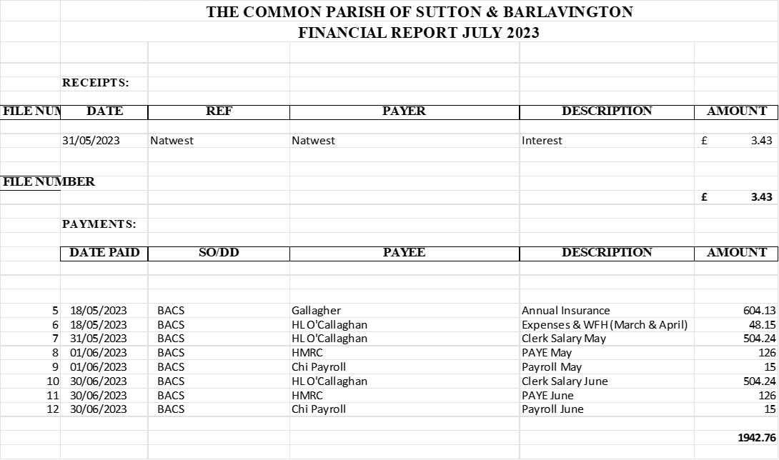

Appendix C

