THE COMMON PARISH COUNCIL OF SUTTON & BARLAVINGTON
MINUTES OF THE PARISH MEETING
WEDNESDAY 26 JANUARY AT 7.30pm

In attendance: Cllr Andrews, Cllr Brown, Cllr Cross, Cllr Parkes, Cllr Snowdon, Hannah-Louise O’Callaghan (Clerk), County Cllr Richardson, District Cllr Sutton  Agenda Item 1: Apologies for Absence  None  Agenda Item 2: Code of Conduct  - Declaration of Members’ Personal Interests on items included in the Agenda and Dispensation Requests - None  Agenda Item 3: Approval of Minutes of meeting held on 1st November 2021  On a proposal by Cllr Brown and seconded by Cllr Parkes it was RESOLVED that the minutes of the meeting held on 1st November 2021 be accepted as a true record of proceedings.  Agenda Item 4: Update on Matters carried forward  - Queens Green Canopy  Cllr Snowdon reported that he had visited the potential site with the councillor from Bury, Chris Daykin, it was reported that the approximate cost for 7 trees and deer protection would be circa £700 split between the two parishes. County Cllr Sutton suggested that the parish council speak to Penny Plant the tree officer as she may be able to help with the provision of trees or advise whether any grants are available. Cllr Snowdon to follow up.  Clerk reported that an email had been received in response to Cllr Cross’s piece in the village news, suggesting that a tree be planted by the bus shelter opposite the White Horse. After discussion it was decided that this was an unsuitable location due to the area available for planting. An alternative location suggested was beside the bridle/footpath outside the gate of the Church.  Reference was made to the Queen’s Jubilee grant however after discussion it was decided that the parish council would apply for a grant to replace one of the benches on the footpath beside the bowling club. Clerk to action and send to Cllr Cross for approval before submission.  - Removal of old website and redirection to new website  Cllr Cross reported that he had spoken to Martin Shepherd and the removal of the old website with reference to the Parish Council was in hand. Clerk to check.  Agenda Item 5: County Councillor Report, Cllr Richardson  County Cllr Richardson reported that Highways have cleared the lanes after the Duncton closure although earth in the ditches at Shopham Bridge still needs removing. Cllr Brown added that Crouch Lane has been cleared as well.  County Cllr Richardson advised that he had been appointed as a special advisor for the member of cabinet for road safety and in this role he will be reviewing the speed limit across the County as well as looking at the trial of quiet lanes around Sutton and Barlavington. Concern was raised regarding additional signage however it was clarified that any signage would replace existing signage and not be in addition.  Cllr Cross raised concerns made by a resident regarding line of site at the crossroads between Coates and Burton Mill Pond. In particular coming from Sutton, visibility at the crossroads is minimal, particularly when dog-walkers cars are parked around the corner on the road to Coates, or when fast traffic comes up the hill from Burton millpond. County Cllr Richardson advised that this should be taken up through the Communities Highways Scheme. Cllr Brown to follow up.  It was reported that the budget meeting would be going to full council in February.  Cllr Cross raised the issue of electric charging points for the village. After discussion it was decided that the parish council would wait to see how this progressed as it was not a straightforward exercise and costs may be incurred by the parish council if not enough usage was made of the points.  Cllr Snowdon asked whether Highways would make the bend at the crossroads towards Coates wider and County Cllr Richardson advised that this again would fall under the Communities Highways Scheme.  Agenda Item 6: District Councillor Report, Cllr Sutton  District Cllr Sutton noted that the electric charging points scheme was being run in conjunction with County and advised that data is showing that the points are not being used as much as expected at this stage.  Planning – SDNPA will shortly be reviewing their local plan and there will be a push on affordable housing. CDC is continuing to work with SDNPA to deliver planning however this area is under-resourced.  District Cllr Sutton highlighted that a warm home scheme is available for those on an income of less than £30,000 per annum and subject to an EPC rating some households locally may be eligible. The scheme is being run by Chichester and Arun Citizens Advice Bureau and more information can be found on their website. There is also a warm home discount of up to £140 available and a rates reduction scheme. District Cllr Sutton also reported that free school meals vouchers are available during the February half term. All information can be found on the CDC website or is signposted from there.  The Parish Council highlighted concerns over outstanding planning applications and the procedures being taken. District Cllr Sutton asked that any concerns be forwarded to him via email so that he could follow these up individually The Parish Council requested that the Clerk forward details of the outstanding case at Sutton Court Barn.  Agenda Item 7: Planning Update  No update  Agenda Item 8: Highways, Footpaths and Village Maintenance Update  Cllr Brown reported that the bottom of Sutton Hollow has been cleared and the telephone box is due to be updated when the weather improves.  Agenda Item 9: Finance  - To approve Clerks salary and expenses – Appendix A  On a proposal by Cllr Parkes and seconded by Cllr Brown, Clerks salary and expenses were approved by the Council  - To note and approve income and expenditure report – Appendix B  On a proposal by Cllr Andrews and seconded by Cllr Parkes, Council approved the income and expenditure report  - To approve the regular Bank Reconciliation – Appendix C  On a proposal by Cllr Snowdon and seconded by Cllr Parkes, the Bank Reconciliation was approved by the Council  - To set the Precept  It was noted that at the previous meeting in November Council agreed to keep the Precept at £8,218  This was approved UNANIMOUSLY. Clerk to communicate accordingly.  - Consideration of purchase of new laptop for Clerk  Clerk informed the Council that the current laptop was now over 6 years old and was very slow. In addition the Council are using a memory stick to back up documents which is time consuming and not in adherence with current guidelines. Clerk asked Council to consider the purchase of a new laptop for £299 plus the purchase of a mouse. This would include a year’s subscription to Microsoft 365 for backing up documents securely. This cost would be £11.28 monthly once the free period expired and could be considered at this point. After discussion Council agreed UNANIMOUSLY that Clerk could go ahead with this purchase and that it would be reimbursed by the Council.  Agenda Item 10: Correspondence  Council acknowledged receipt of the following correspondence:  - Fire Service Consultation  - Big Data Police presentation  - SDNPA Self-Build and Custom Housebuilding Consultation  - Eroica Cycling Event, Goodwood  - Tree planting  - Electric ChargePoint Email  Agenda Item 11: Matters arising not dealt with elsewhere on the agenda  It was agreed that the Parish Meeting would take place on either 25th or 26th May and that both District and County Cllrs would be invited to speak to update the Parish. Cllr Cross to purchase drinks and Cllr Brown to purchase nibbles. Clerk to book the village hall according to what dates were available.  Agenda Item 12: Public Questions  None  Agenda Item 13: Any other matters for information only  None  Agenda Item 14: DATE OF THE NEXT MEETING 23rd March 2022  Meeting finished at 20.30  Appendices and Attachments  Monthly Bank Reconciliation and Monthly Income and Expenditure Report | ACTION  Cllr Snowdon  Clerk  Cllr Cross  Clerk  Cllr Brown  Clerk  Clerk  Clerk  Clerk

Appendix A

Clerk Salary and Expenses

Clerks Salary 1 – 30th November 2021
Net Salary £543.75
PAYE £4.20
Total £547.95

Clerks Salary 1- 31st December 2021
Net Salary £543.55
PAYE £4.40
Total £547.95

Paid by Standing Order on last working day of the month

Clerks Expenses November/December

Paid after the meeting

Date | Detail | Reason | Cost ex VAT (£) | VAT (£) | Cost inc VAT (£)
27/1/22 | Working from home allowance (November) | As per contract | 18.00 | 0 | 18.00
27/1/22 | Working from home allowance (December) | As per contract | 18.00 | 0 | 18.00
Total |  |  | 36.00 | 0 | 36.00

Appendix B

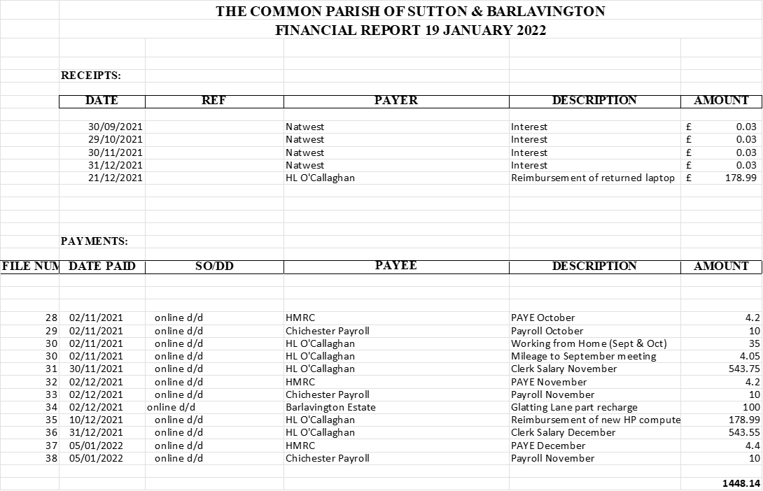

Appendix C

