THE COMMON PARISH COUNCIL OF SUTTON & BARLAVINGTON

**MEMBERS OF THE COMMON PARISH OF SUTTON & BARLAVINGTON ARE HEREBY SUMMONED TO THE FULL COUNCIL MEETING OF THE COMMON PARISH OF SUTTON & BARLAVINGTON ON**

**MONDAY 2nd NOVEMBER 2020 AT 7.30 PM**

Due to the Coronavirus Government guidelines the meeting will be held via Zoom video conference call

**AGENDA**

1. Apologies for Absence
2. Code of Conduct

Declaration of Members’ disclosable pecuniary interests and other interests on items included on the Agenda.

1. Approval of Minutes of meeting held on 14th September 2020
2. Update on matters carried forward:
3. Website
4. Finance
5. To approve Clerks salary and expenses – **Appendix A**
6. To note and approve income and expenditure report **– Appendix B**
7. To approve the regularBank Reconciliation **– Appendix C**
8. To review Budget ahead of Precept discussions
9. Questions to County Councillor (Report to be submitted in advance)
10. Questions to District Councillor (Report to be submitted in advance)
11. Planning Update
12. Correspondence
13. To agree meeting dates 2021 – proposed dates: 11th January, 8th March, 10th May, 5th July, 6th September, 1st November 2021
14. Matters arising not dealt with on the Agenda
15. Public Questions (10 Minutes)
16. Any other matters for information only
17. Date of next Meeting tbc

Signed:

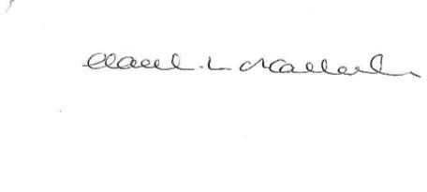

HL O’Callaghan

Clerk & RFO

**Appendix A**

**Clerk Salary and Expenses**

**Clerks Salary 1 – 30th September 2020**

Net Salary £576.09 (to include back pay)

**Clerks Salary 1- 31st August 2020**

Net Salary £525.89

**Paid by Standing Order on last working day of the month**

**Clerks Expenses 13th - 1st November 2020**

Paid after the meeting

|  |  |  |  |  |  |
| --- | --- | --- | --- | --- | --- |
| **Date** | **Detail** | **Reason** | **Cost ex VAT (£)** | **VAT (£)** | **Cost inc VAT (£)** |
| 2/11/20 | Working from home allowance (September) | As per contract | 18.00 | 0 | 18.00 |
| 2/11/20 | Working from home allowance (October) | As per contract | 18.00 | 0 | 18.00 |
| **Total** |  |  | **36.00** | **0** | **36.00** |

**Appendix B**



**Appendix C**

