THE COMMON PARISH COUNCIL OF SUTTON & BARLAVINGTON

**MEMBERS OF THE COMMON PARISH OF SUTTON & BARLAVINGTON ARE HEREBY SUMMONED TO THE FULL COUNCIL MEETING OF THE COMMON PARISH OF SUTTON & BARLAVINGTON ON**

**MONDAY 9th MARCH 2020 AT 7.30 PM ST JOHNS CHURCH, SUTTON**

**AGENDA**

1. Apologies for Absence
2. Code of Conduct

Declaration of Members’ disclosable pecuniary interests and other interests on items included on the Agenda.

1. Approval of Minutes of meeting held on 15th January 2020
2. Update on matters carried forward from previous meeting:
3. PCSO Invitation to AGM, 4th May 2020
4. Repair of fingerpost
5. Website
6. County Councillor Report (10 Minutes)
7. District Councillor Report (10 Minutes)
8. VE Day Celebrations – application for grant funding
9. Highways and Footpaths & Village Maintenance Update
10. Tree Warden Update
11. Planning Update
12. Planning permission for solar panels
13. Consultations
14. Correspondence
15. Finance
    1. To note Clerk’s salary and expenses – **Appendix A**
    2. To note and approve Income and Expenditure Report – **Appendix B**
    3. To approve Bank Reconciliation – **Appendix C**
16. Matters arising not dealt with on the Agenda
17. Public Questions (10 Minutes)
18. Any other matters for information only
19. Date of next Meeting – Wednesday 6th May 2020

Signed:

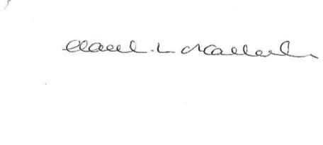

HL O’Callaghan

Clerk & RFO

**Appendix A**

**Clerk Salary and Expenses**

**Clerks Salary 1 – 31st January 2020**

Net Salary @£13.15 per hour £512.85

**Clerks Salary 1- 29th February 2020**

Net Salary @£13.15 per hour £512.85

**Paid by Standing Order on last working day of the month**



**Appendix B**



**Appendix C**

