THE COMMON PARISH COUNCIL OF SUTTON & BARLAVINGTON

**MEMBERS OF THE COMMON PARISH OF SUTTON & BARLAVINGTON ARE HEREBY SUMMONED TO THE FULL COUNCIL MEETING OF THE COMMON PARISH OF SUTTON & BARLAVINGTON ON**

**MONDAY 14 SEPTEMBER 2020 AT 7.30 PM**

Due to the Coronavirus Government guidelines the meeting will be held via Zoom video conference call

**AGENDA**

1. Apologies for Absence
2. Code of Conduct

Declaration of Members’ disclosable pecuniary interests and other interests on items included on the Agenda.

1. Approval of Minutes of meeting held on 6th July 2020
2. Update on matters carried forward:
3. Website
4. Finance
5. To approve Clerks salary and expenses – **Appendix A**
6. To note and approve income and expenditure report **– Appendix B**
7. To approve the regularBank Reconciliation **– Appendix C**
8. Questions to County Councillor (Report to be submitted in advance)
9. Questions to District Councillor (Report to be submitted in advance)
10. Planning Update
11. Correspondence
12. White Horse/Bus Shelter
13. Matters arising not dealt with on the Agenda
14. Public Questions (10 Minutes)
15. Any other matters for information only
16. Date of next Meeting – Monday 2nd November 2020

Signed:

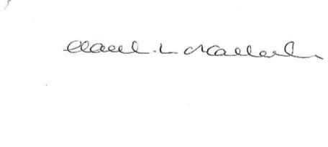

HL O’Callaghan

Clerk & RFO

**Appendix A**

**Clerk Salary and Expenses**

**Clerks Salary 1 – 31st July 2020**

Net Salary @£13.15 per hour £512.85

**Clerks Salary 1- 31st August 2020**

Net Salary @£13.15 per hour £512.85

**Paid by Standing Order on last working day of the month**

**Clerks Expenses 6 July - 13th September 2020**

Paid after the meeting

|  |  |  |  |  |  |
| --- | --- | --- | --- | --- | --- |
| **Date** | **Detail** | **Reason** | **Cost ex VAT (£)** | **VAT (£)** | **Cost inc VAT (£)** |
| 14/9/20 | Working from home allowance (July) | As per contract | 18.00 | 0 | 18.00 |
| 14/9/20 | Working from home allowance (August) | As per contract | 18.00 | 0 | 18.00 |
| **Total** |  |  | **36.00** | **0** | **36.00** |

**Appendix B**



**Appendix C**

